**Dark theme**

A dark theme is a low-light UI that displays mostly dark surfaces.

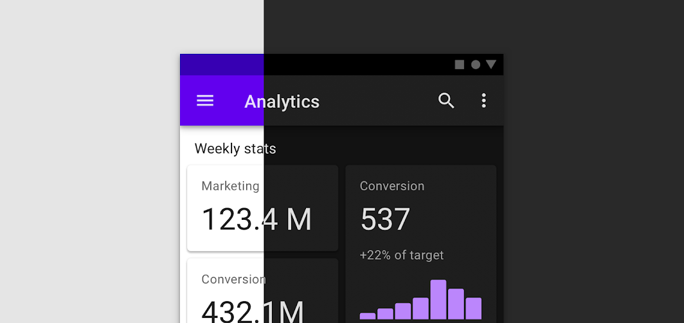

A light and dark theme UI

Contents

* [Usage](https://m2.material.io/design/color/dark-theme.html#usage)
* [Anatomy](https://m2.material.io/design/color/dark-theme.html#anatomy)
* [Behavior](https://m2.material.io/design/color/dark-theme.html#behavior)
* [Properties](https://m2.material.io/design/color/dark-theme.html#properties)
* [UI application](https://m2.material.io/design/color/dark-theme.html#ui-application)
* [Custom application](https://m2.material.io/design/color/dark-theme.html#custom-application)
* [States](https://m2.material.io/design/color/dark-theme.html#states)
* [Resources](https://m2.material.io/design/color/dark-theme.html#resources)
* [Implementation](https://m2.material.io/design/color/dark-theme.html#implementation)

**Usage**link

A dark theme displays dark surfaces across the majority of a UI. It's designed to be a supplemental mode to a default (or light) theme.

Dark themes reduce the luminance emitted by device screens, while still meeting minimum color contrast ratios. They help improve visual ergonomics by reducing eye strain, adjusting brightness to current lighting conditions, and facilitating screen use in dark environments – all while conserving battery power. Devices with OLED screens benefit from the ability to turn off black pixels at any time of day.

**Principles**

Use dark grey – rather than black – to express elevation and space in an environment with a wider range of depth. Apply limited color...

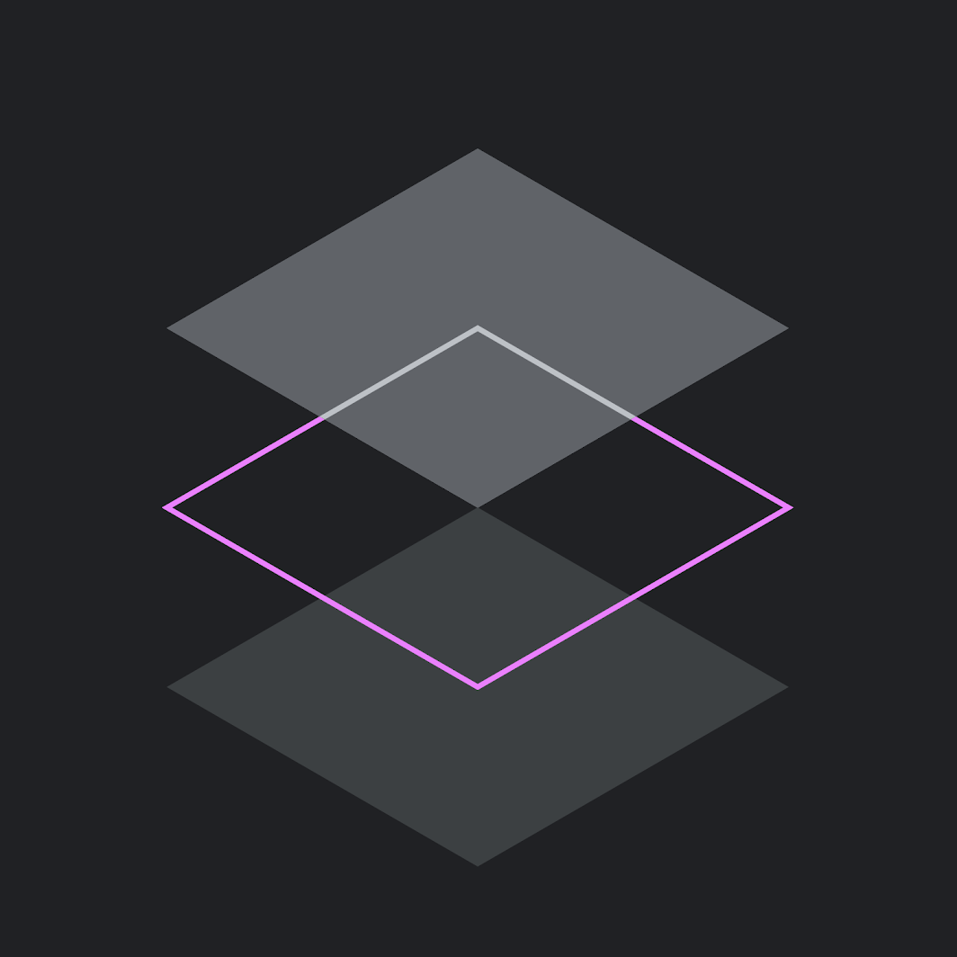

**Darken with grey**

Use dark grey - rather than black - to express elevation and space in an environment with a wider range of depth.

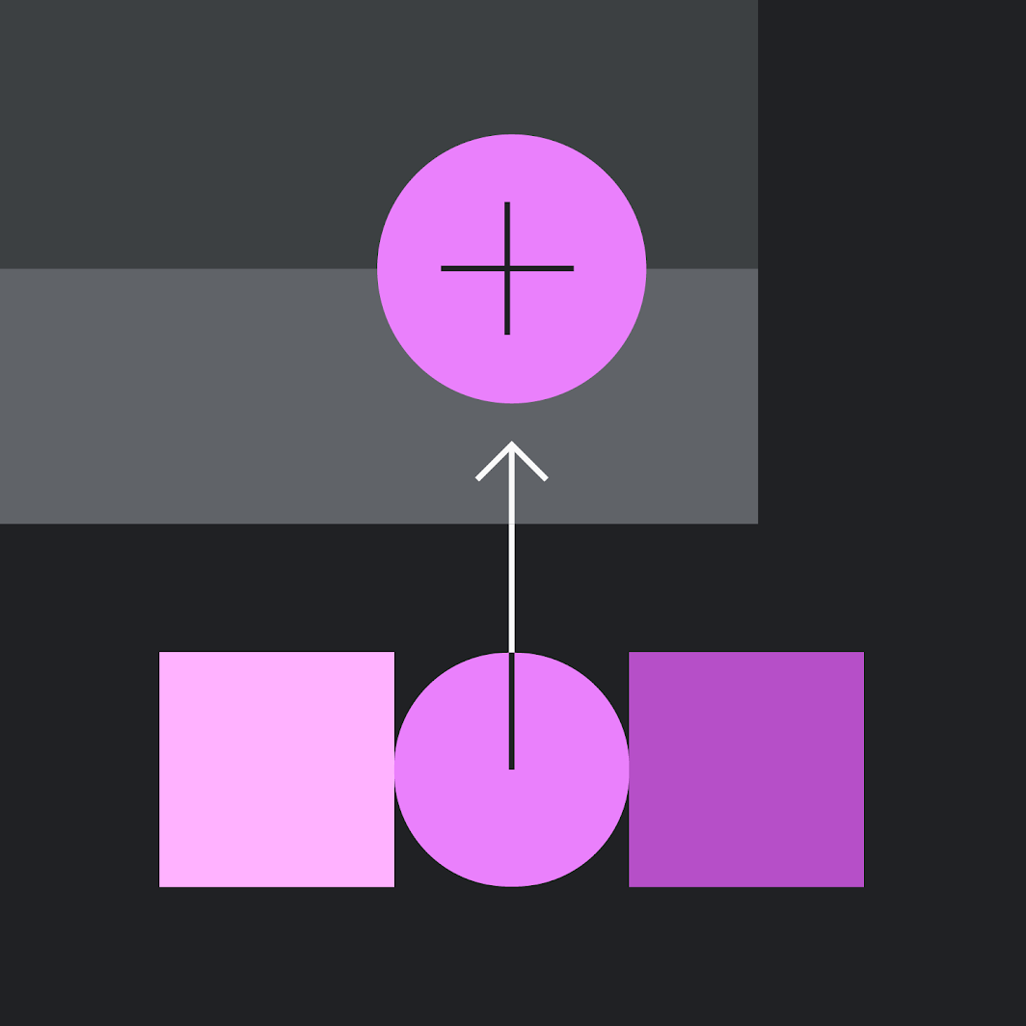

**Color with accents**

Apply limited color accents in dark theme UIs, so the majority of space is dedicated to dark surfaces.

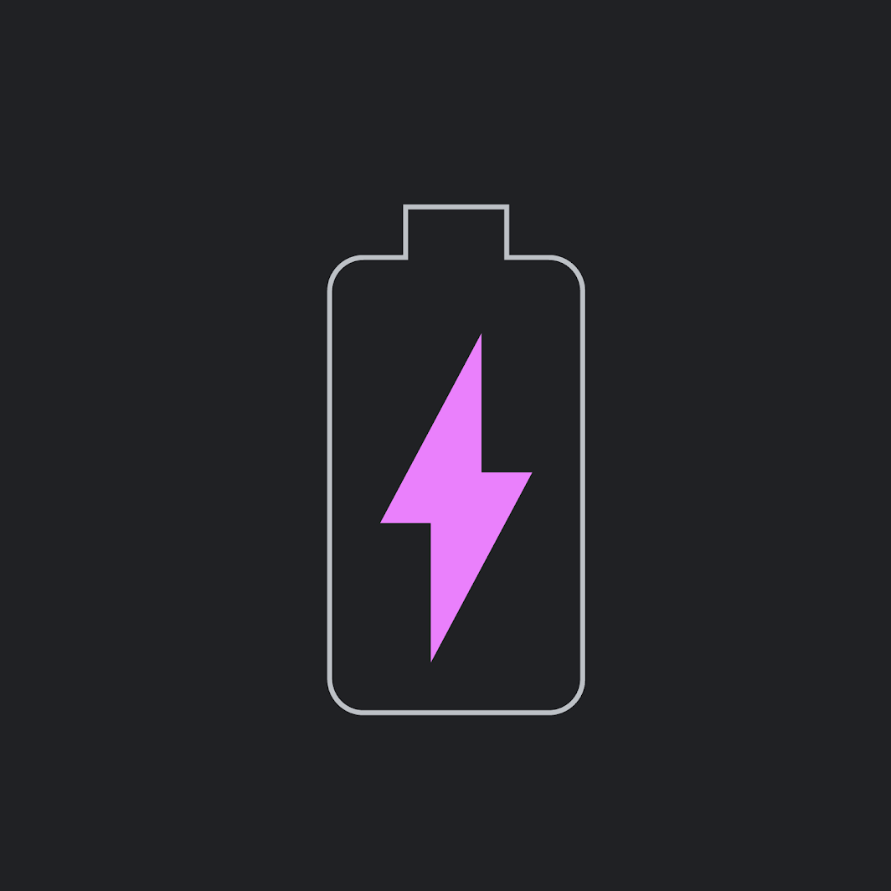

**Conserve energy**

In products that require efficiency (such as devices with OLED screens), conserve battery life by reducing the use of light pixels.

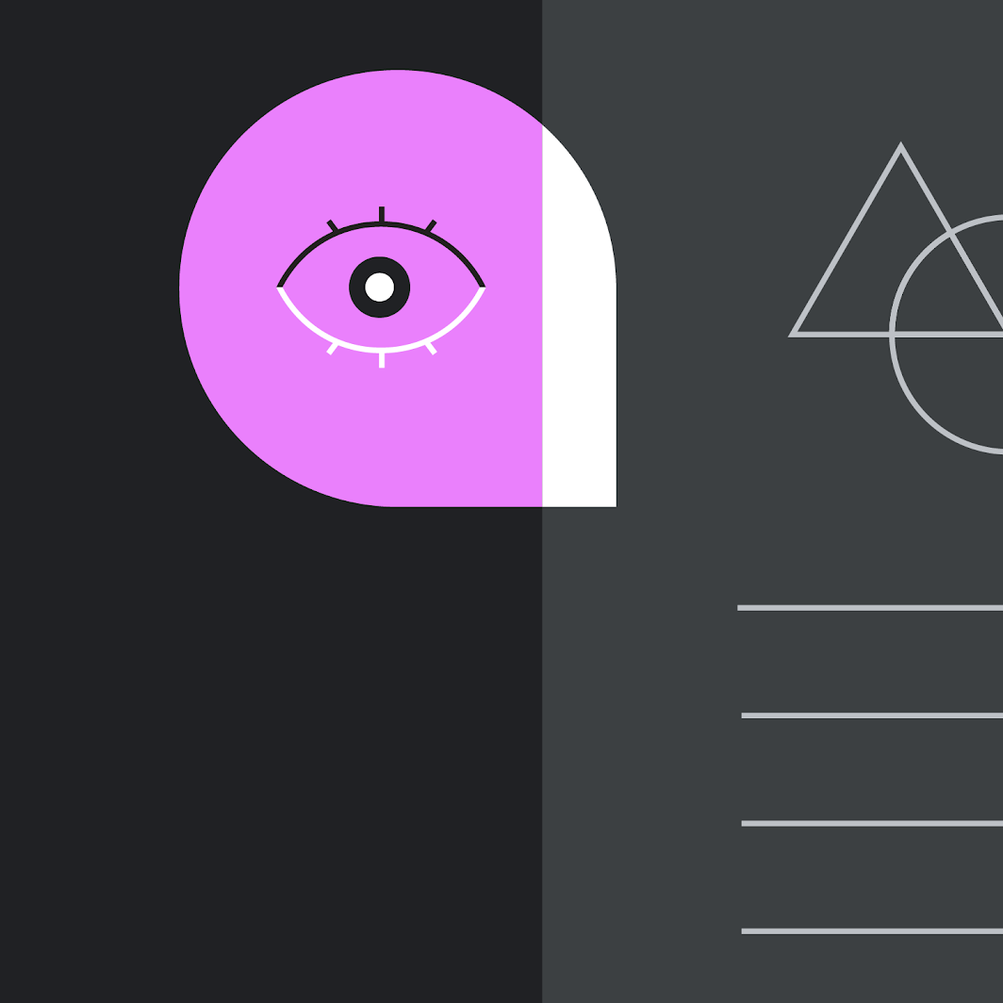

**Enhance accessibility**

Accommodate regular dark theme users (such as those with low vision), by meeting accessibility color contrast standards.

**Properties**

Understanding Contrast Related Link arrow\_downward Material Design dark themes are defined by the following properties:

Material Design dark themes are defined by the following properties:

* **Contrast:** Dark surfaces and 100% white body text have a contrast level of at least 15.8:1
* **Depth:** At higher levels of elevation, components express depth by displaying lighter surface colors
* **Desaturation:** Primary colors are desaturated so they pass the Web Content Accessibility Guidelines’ (WCAG) AA standard of at least 4.5:1 (when used with body text) at all elevation levels
* **Limited color:** Large surfaces use a dark surface color, with limited color accents (light, desaturated and bright, saturated colors)

[World Wide Web Consortium (W3C)](https://www.w3.org/TR/UNDERSTANDING-WCAG20/visual-audio-contrast-contrast.html" \o "World Wide Web Consortium (W3C)" \t "_blank)

[Understanding Contrast](https://www.w3.org/TR/UNDERSTANDING-WCAG20/visual-audio-contrast-contrast.html" \o "World Wide Web Consortium (W3C)" \t "_blank)

[Related linkarrow\_downward](https://www.w3.org/TR/UNDERSTANDING-WCAG20/visual-audio-contrast-contrast.html" \o "World Wide Web Consortium (W3C)" \t "_blank)

**Anatomy**link

Dark theme UIs use predominantly dark surfaces, with sparse color accents. They emit low levels of light while maintaining a high standard of usability.

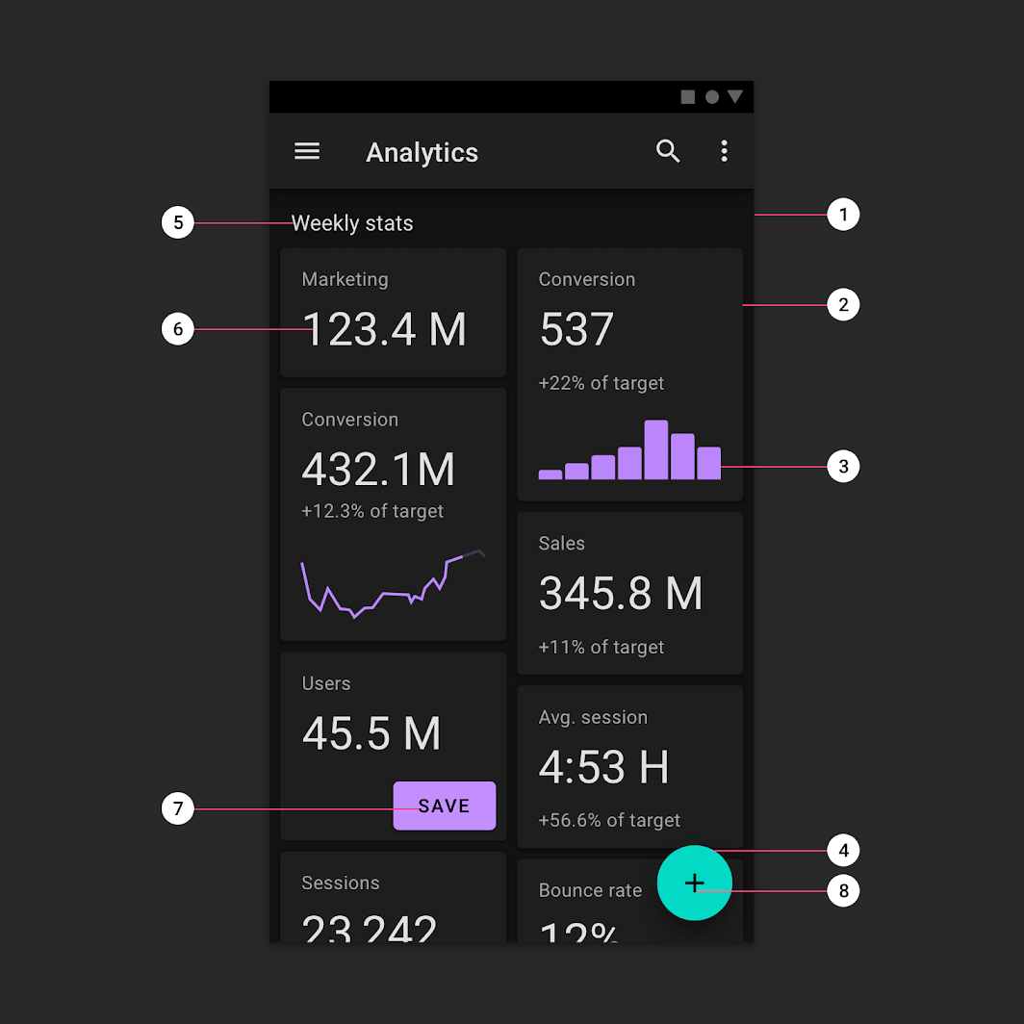

1. Background (0dp elevation surface overlay)  
2. Surface (with 1dp elevation surface overlay)  
3. Primary  
4. Secondary  
5. On background  
6. On Surface  
7. On Primary  
8. On Secondary

**Behavior**link

A dark theme can be turned on (or off) using a control that is displayed:

* Prominently, using an icon toggle to turn the theme on or off
* With reduced prominence, with a toggle placed inside a menu or an app’s settings

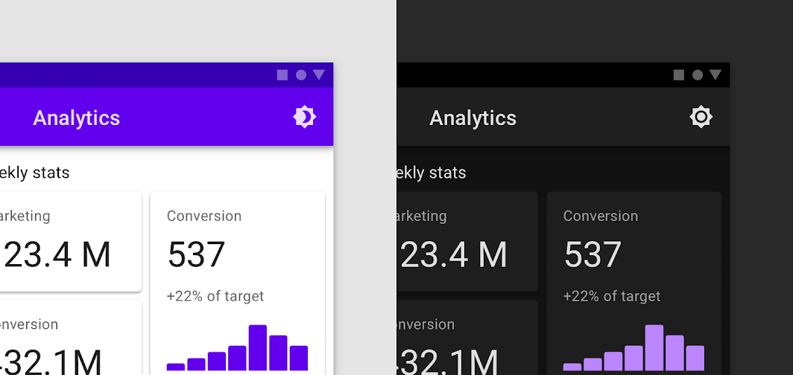

A dark theme toggle in a top app bar

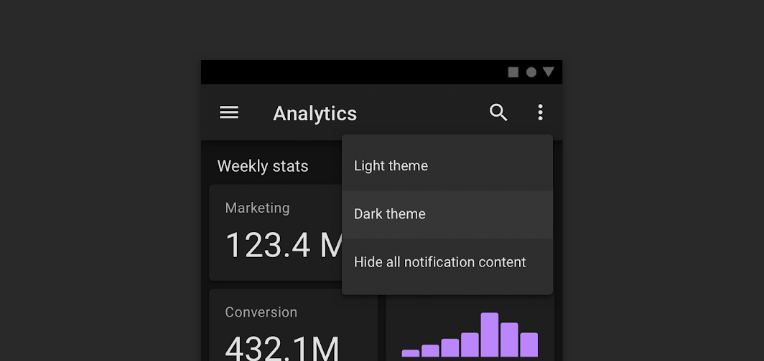

A dark theme toggle inside an overflow menu

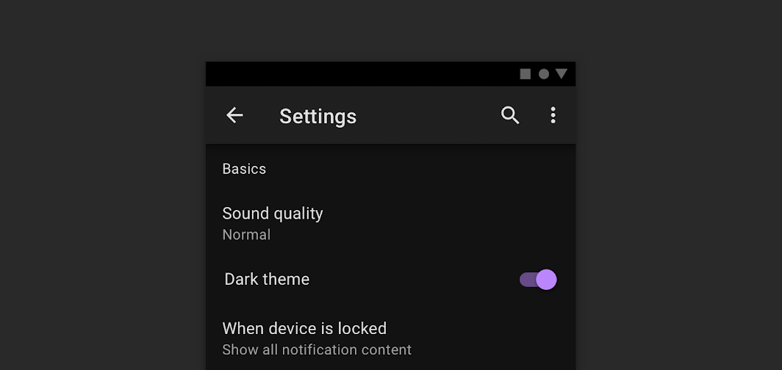

A dark theme toggle inside an app's settings

**Properties**link

A dark theme uses dark grey, rather than black, as the primary surface color for components. Dark grey surfaces can express a wider range of color, elevation, and depth, because it's easier to see shadows on grey (instead of black).

Dark grey surfaces also reduce eye strain, as light text on a dark grey surface has less contrast than light text on a black surface.

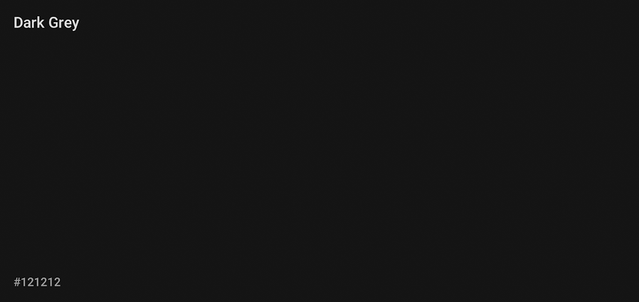

The recommended dark theme surface color is #121212.

**Elevation**

Elevation is the relative distance between two surfaces along the z-axis. Related Article arrow\_downward In a dark theme, components retain the same default elevation levels...

In a dark theme, components retain the same default elevation levels and shadows as components in lighter themes. However, in a dark theme, the surfaces of different elevation levels are illuminated differently.

**Higher elevation, lighter surface**

The higher a surface's elevation (raising it closer to an implied light source), the lighter that surface becomes. That lightness is expressed through the application of a semi-transparent [overlay](https://material.io/design/interaction/states.html#anatomy) using the [On Surface](https://material.io/design/color/dark-theme.html#ui-application) color.

volume\_off

As a surface raises in elevation, it becomes lighter in color.

A dark theme surface is constructed by placing a semi-transparent overlay over a component surface.

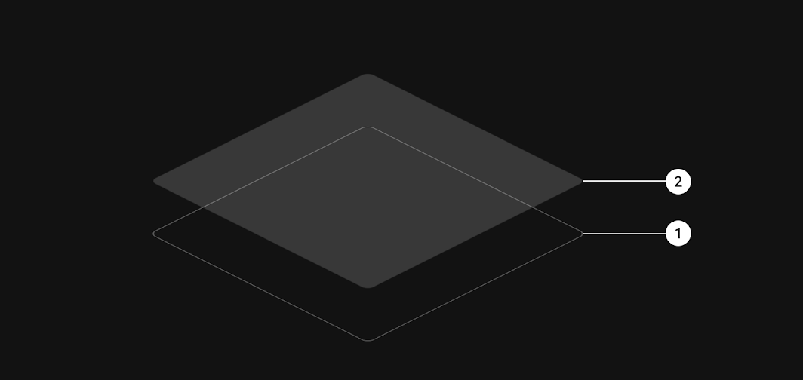

A surface becomes lighter with the application of a semi-transparent white overlay.  
1. Surface  
2. Elevation overlay

An overlay on a surface also makes it easier to distinguish elevation between components and to see shadows. Overlays add contrast between surfaces and their shadows, making the edges of each surface more apparent.

volume\_off

Default themes use shadows to express elevation, while a dark theme also expresses elevation by adjusting the surface color.

These surface overlay values are designed to maximize legibility, while ensuring the different elevation levels are discernible from one another.

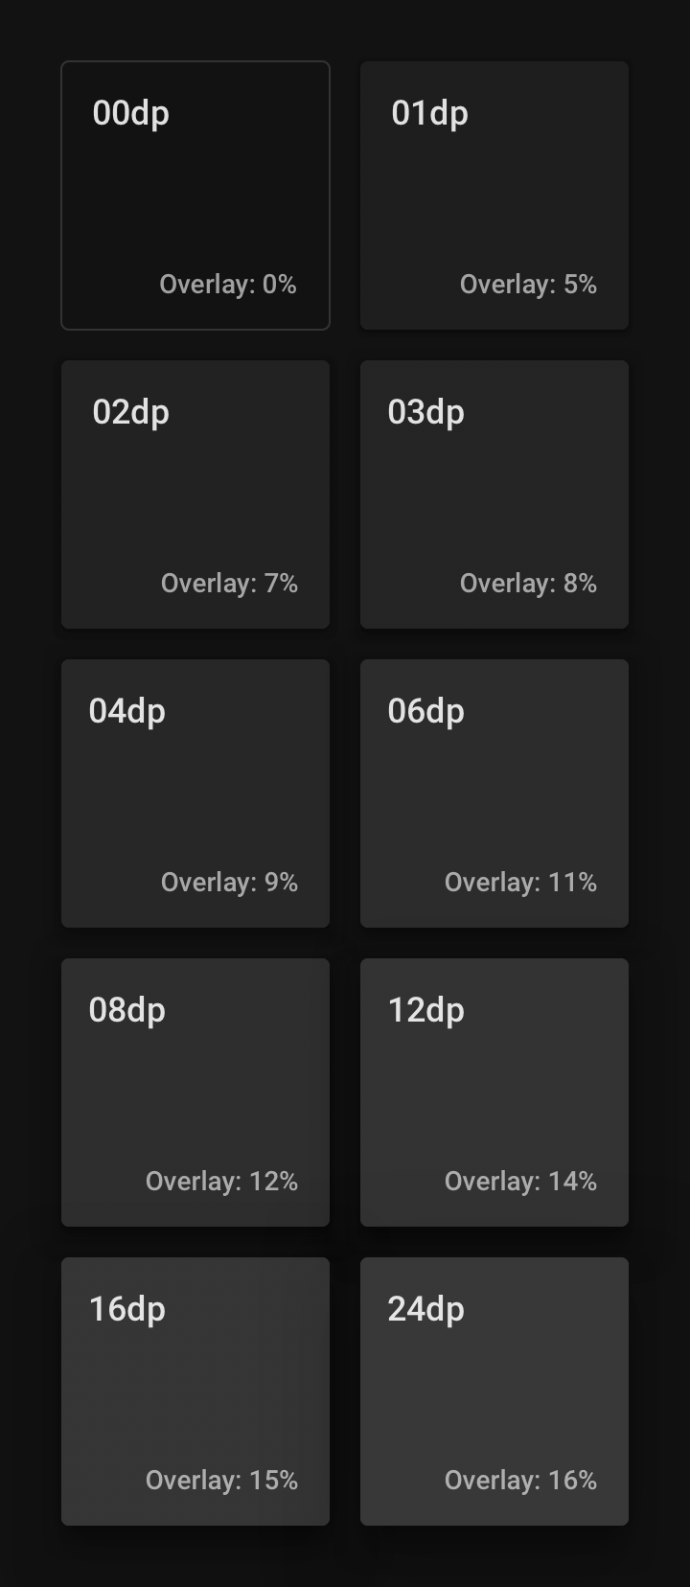

Elevation overlay transparencies range from 0% for the lowest level to 16% for the highest level.

| Elevation level | White overlay transparency |
| --- | --- |
| 00dp | 0% |
| 01dp | 5% |
| 02dp | 7% |
| 03dp | 8% |
| 04dp | 9% |
| 06dp | 11% |
| 08dp | 12% |
| 12dp | 14% |
| 16dp | 15% |
| 24dp | 16% |

Overlays clarify the elevation difference between components.

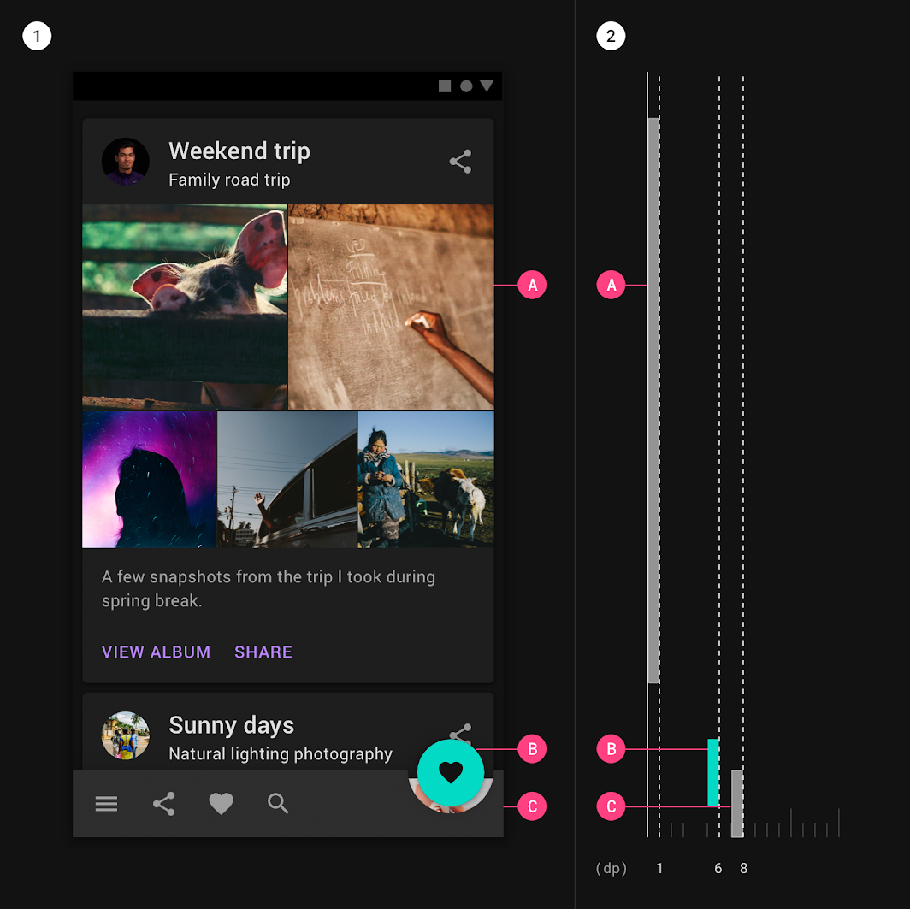

A. A card at 1dp elevation with 5% overlay  
B. A floating action button at 6dp using a secondary color without an overlay  
C. A bottom app bar at 8dp elevation with a 12% overlay

The elevation overlays are not applied to component surfaces that use primary or secondary colors.

In a dark theme, shadows remain dark to accurately represent a cast shadow.

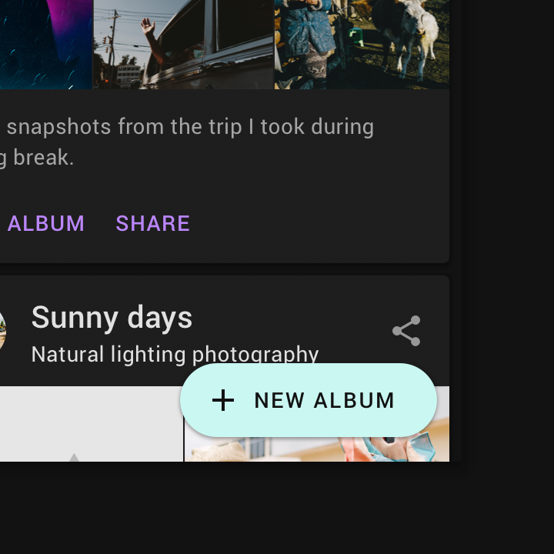

Don'tAvoid elevation overlays on components that use a primary or secondary color for their surface container.

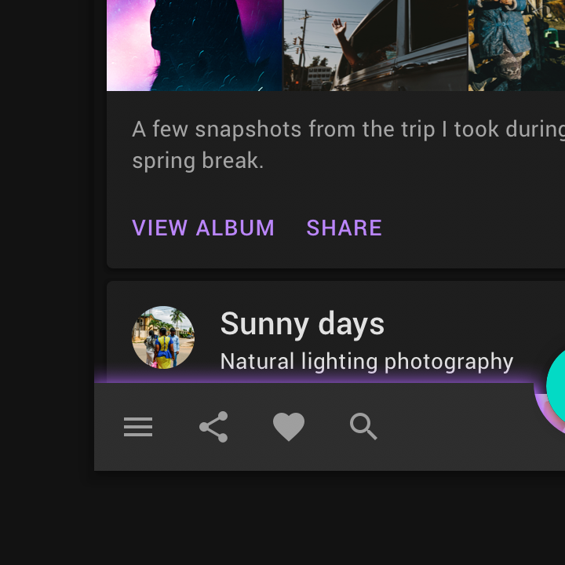

Don'tDon't use light glows in place of dark shadows to express elevation, because they don’t accurately represent elevation the way a cast shadow does.

[Elevation](https://m2.material.io/design/environment/elevation.html" \o "Elevation" \t "_self)

[Elevation is the relative distance between two surfaces along the z-axis.](https://m2.material.io/design/environment/elevation.html" \o "Elevation" \t "_self)

[Related articlearrow\_downward](https://m2.material.io/design/environment/elevation.html" \o "Elevation" \t "_self)

**Accessibility and contrast**

Accessibility in design allows users of diverse abilities to navigate, understand, and use your UI successfully. Related Article arrow\_downward Dark theme surfaces must be dark...

Dark theme surfaces must be dark enough to display white text. They should use a contrast level of at least 15.8:1 between text and the background. This ensures that body text passes WCAG's AA standard of at least 4.5:1 when applied to surfaces at the highest (and lightest) elevation.

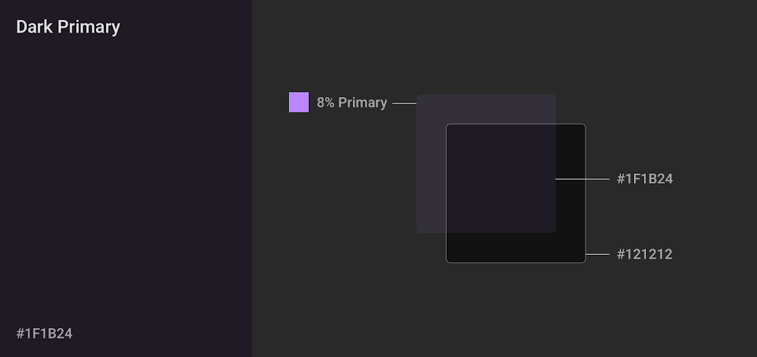

To create branded dark surfaces, overlay the primary brand color at a low opacity over the recommended dark theme surface color (#121212). The color #1F1B24 is the result of combining the dark theme surface color #121212 and the 8% Primary color.

If the background color is not dark enough to meet a contrast level of at least 15.8:1 between white text and the surface, text at the highest (and lightest) elevated surface won't pass the 4.5:1 standard.

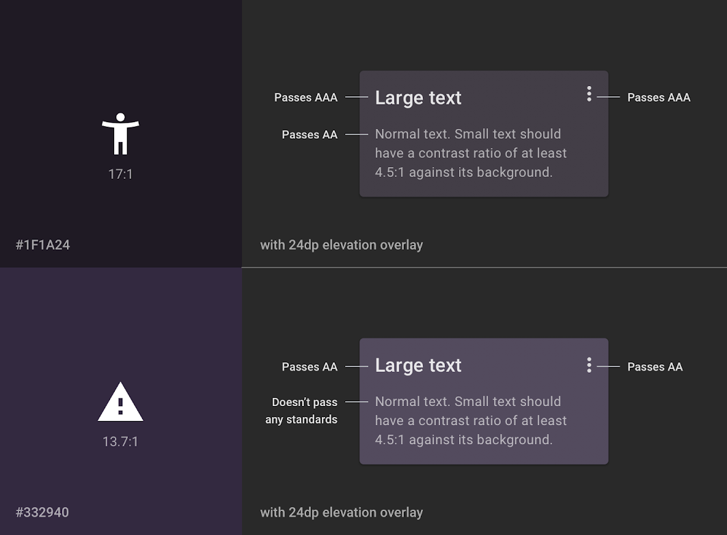

CautionEnsure that the background color is dark enough so that body text meets a contrast level of at least 4.5:1 (AA) on the highest elevated surface (24dp).

UIs that require efficient battery usage can use true black. In these cases, some devices (such as wearables with OLED screens) can turn off any pixels that display black to conserve battery power.

volume\_off

CautionOn OLED screens, turning pixels on and off can cause a delay when the screen is scrolled, making the pixels blur.

[Accessibility](https://m2.material.io/design/usability/accessibility.html" \o "Accessibility" \t "_self)

[Allow users of diverse abilities to navigate, understand, and use your UI successfully.](https://m2.material.io/design/usability/accessibility.html" \o "Accessibility" \t "_self)

[Related articlearrow\_downward](https://m2.material.io/design/usability/accessibility.html" \o "Accessibility" \t "_self)

**UI application**link

**Theme colors**

Color plays an important role in text legibility. Related Article arrow\_downward All dark theme colors should display elements with sufficient contrast, passing WCAG's AA standard...

All dark theme colors should display elements with sufficient contrast, passing WCAG's AA standard of at least 4.5:1 for body text when applied to all elevation surfaces.

**Desaturated colors for accessibility**

A dark theme should avoid using saturated colors, as they don't pass WCAG's accessibility standard of at least 4.5:1 for body text against dark surfaces. Saturated colors also produce optical vibrations against a dark background, which can induce eye strain.

Instead, desaturated colors can be used as a more legible alternative.

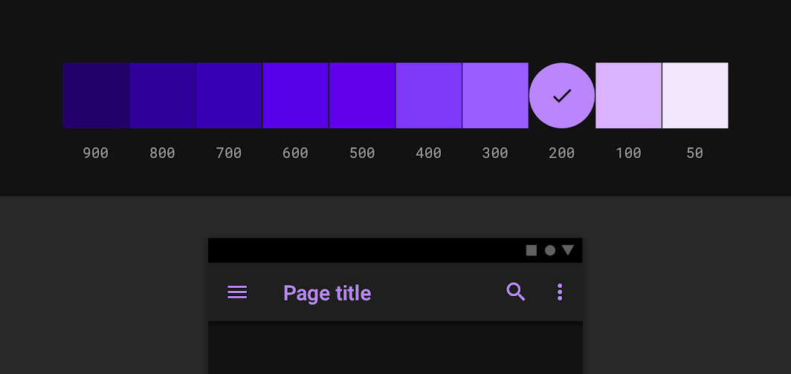

Less saturated colors from your color palette improve legibility and reduce visual vibration.

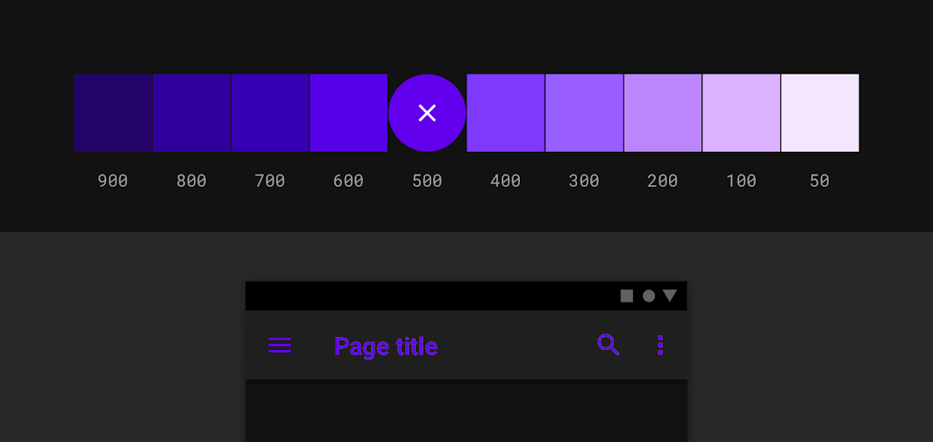

Don'tAvoid using saturated colors that visually vibrate against a dark background.

[Legibility](https://m2.material.io/design/color/text-legibility.html" \l "legibility" \o "Legibility" \t "_self)

[Color plays an important role in text legibility.](https://m2.material.io/design/color/text-legibility.html" \l "legibility" \o "Legibility" \t "_self)

[Related articlearrow\_downward](https://m2.material.io/design/color/text-legibility.html" \l "legibility" \o "Legibility" \t "_self)

**Primary color**

The Material Design color system helps you choose colors for your user interface. Related Article arrow\_downward A primary color is the color displayed most frequently...

A primary color is the color displayed most frequently across your app's screens and components. The baseline Material Design dark theme uses the 200 tone of the primary color (passing the WCAG's AA standard of at least 4.5:1 for normal text, at all elevation surfaces).

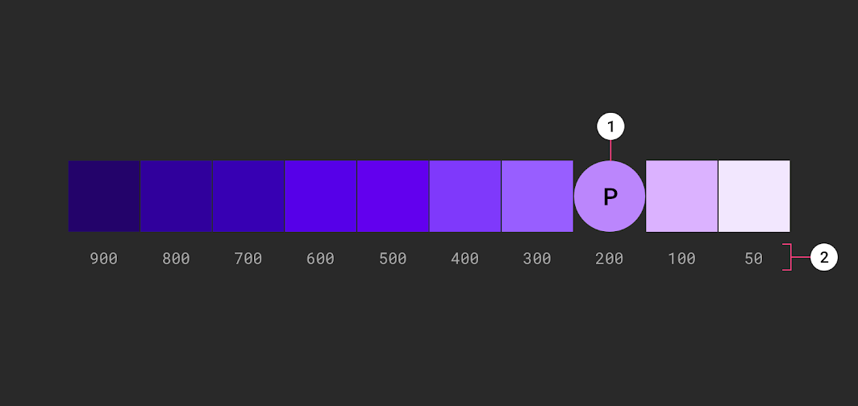

A sample primary palette in a dark theme  
1. Primary color indicator  
2. Tonal variants

**Primary color variants**

Components that have light surfaces can display a variation of your dark theme's primary color.

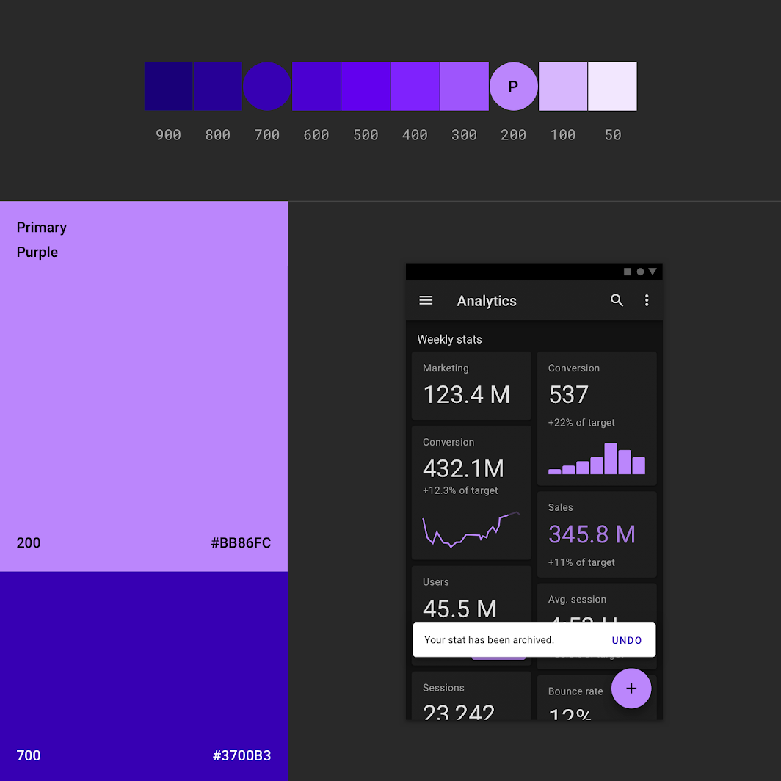

This dark theme UI uses a primary color (Purple 200) and a primary variant (Purple 700).

[The color system](https://m2.material.io/design/color/the-color-system.html" \o "The color system" \t "_self)

[Create a color theme that reflects your brand or style](https://m2.material.io/design/color/the-color-system.html" \o "The color system" \t "_self)

[Related articlearrow\_downward](https://m2.material.io/design/color/the-color-system.html" \o "The color system" \t "_self)

**Secondary color**

A secondary color can be used to accent select parts of your UI. In a dark theme, a secondary color can be desaturated to meet...

A secondary color can be used to accent select parts of your UI. In a dark theme, a secondary color can be desaturated to meet the 4.5:1 contrast level.

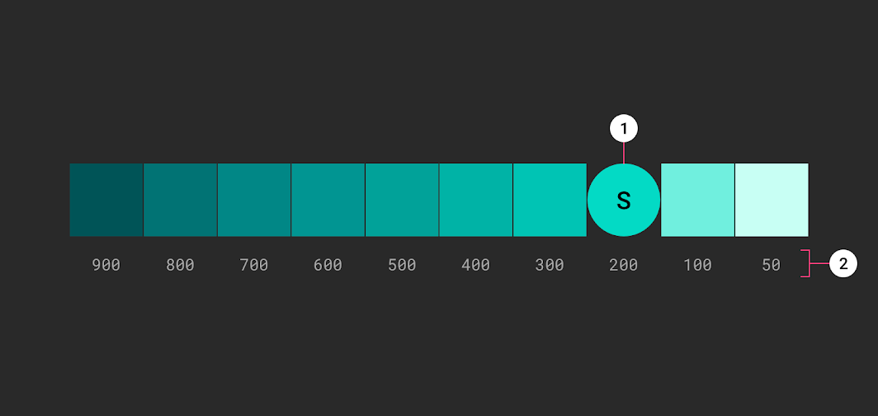

A sample secondary palette in a dark theme  
1. Secondary color indicator  
2. Tonal variants

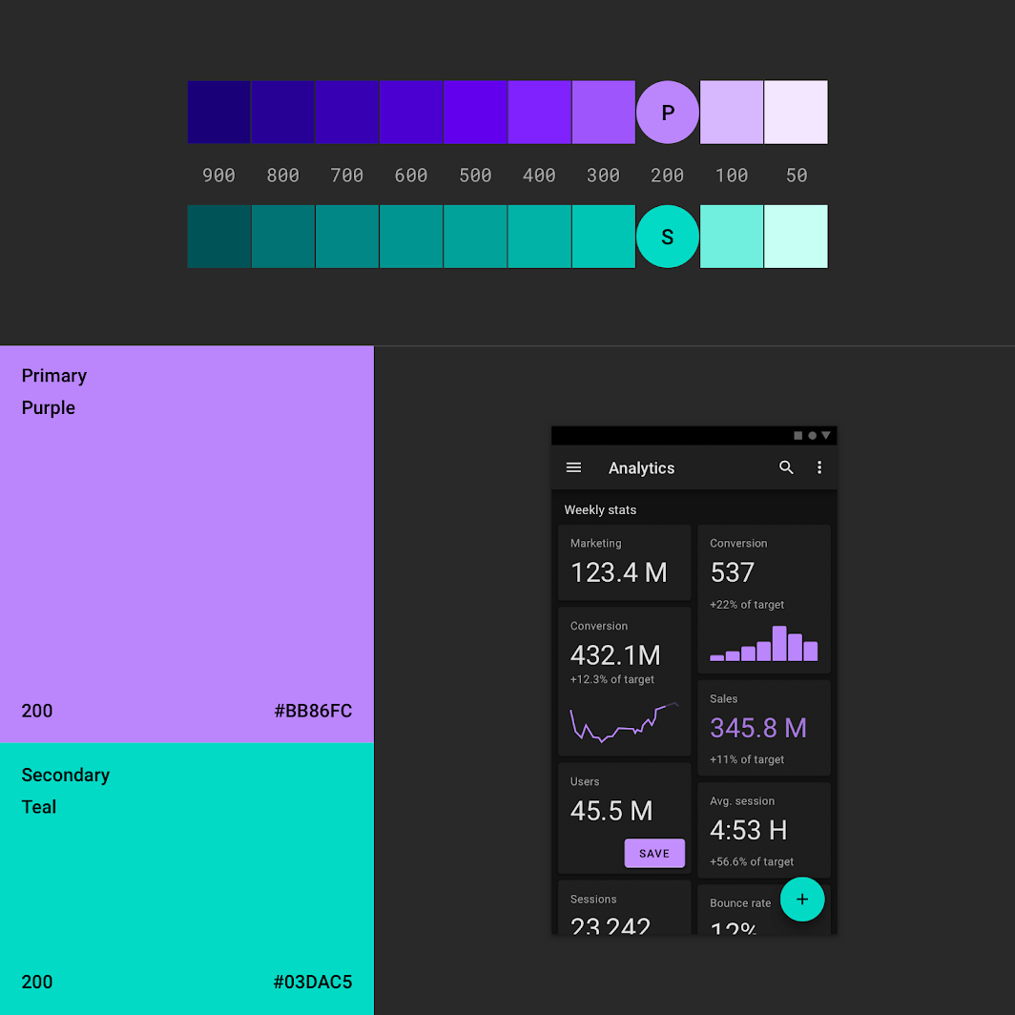

This UI uses a primary color and a secondary color variant.

**Accent color**

In a dark theme, dark surfaces occupy the majority of the UI. Accent colors are typically light (desaturated pastels) or bright (saturated, vivid color) to...

In a dark theme, dark surfaces occupy the majority of the UI. Accent colors are typically light (desaturated pastels) or bright (saturated, vivid color) to help accented elements stand out. They should be used sparingly to accent key elements, such as text or buttons.

**Finding accent colors**

The [color palette generator](https://material.io/design/color/the-color-system.html#tools-for-picking-colors) can be used to create (or view) a color theme. It also generates tonal palettes, which are a range of light to dark color variations, created from your primary and secondary colors. You can select variations of these for your dark theme.

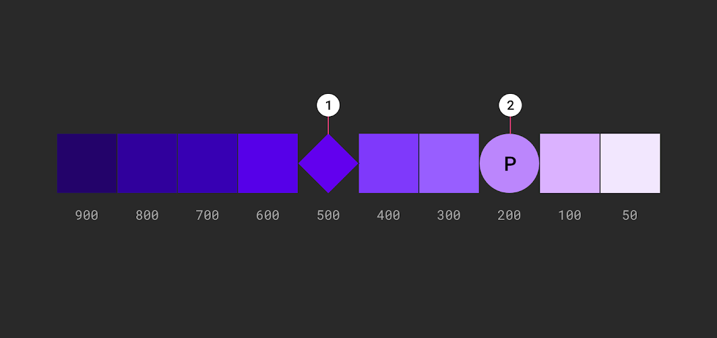

To provide more flexibility and usability in a dark theme, it's recommended to use lighter tones (200-50) in dark theme, rather than your default color theme (saturated tones ranging from 900-500).  
1. Default theme primary color indicator  
2. Dark theme primary color indicator

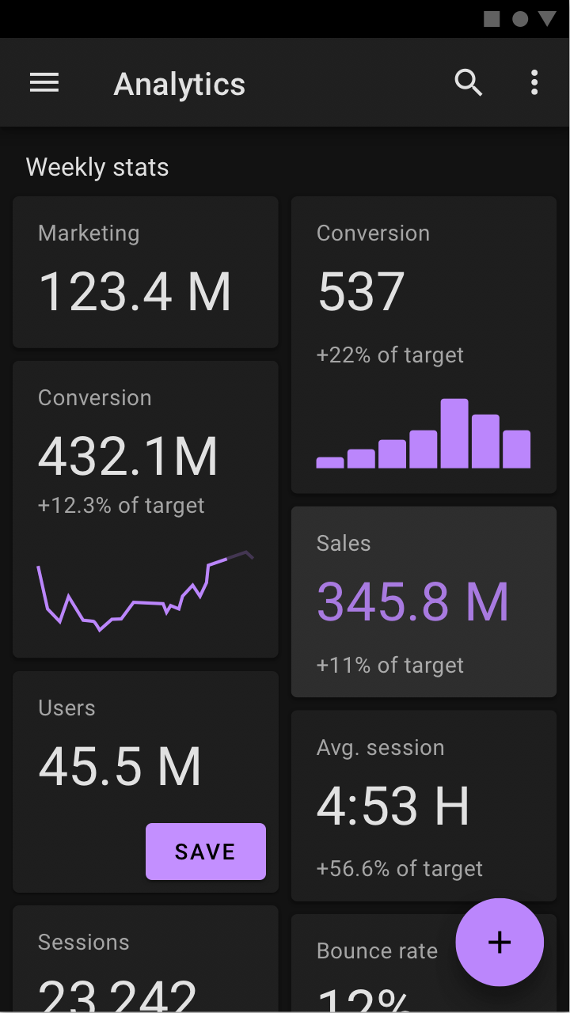

DoLighter tones (colors in the 200-50 range) have better readability on dark theme surfaces (at all elevations).

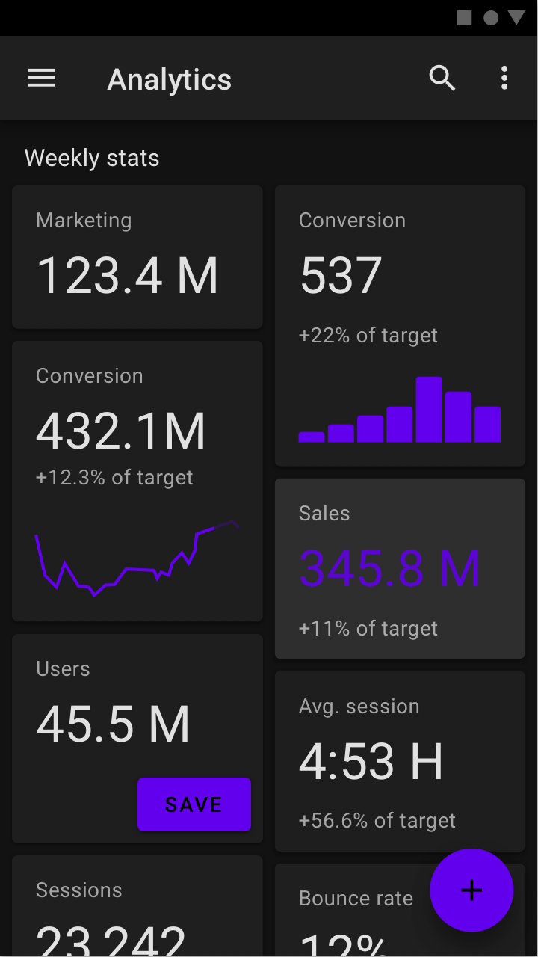

Don'tAvoid using saturated colors on dark themes as they can visually vibrate against dark surfaces.

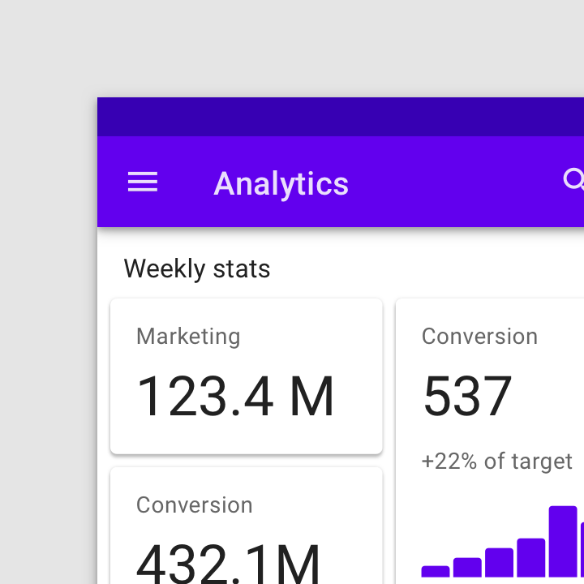

A default theme uses color for the surface of the top app bar.

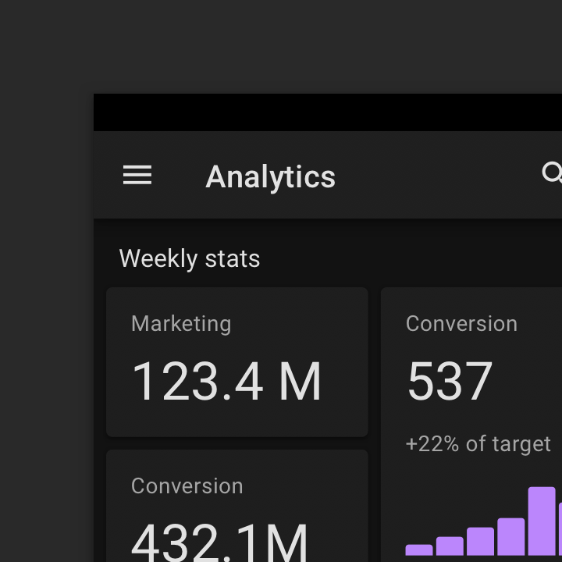

In a dark theme, the surface of the top app bar uses a dark color instead of a primary or secondary color.

**Brand colors**

Owl is an educational app that provides courses for people who want to explore and learn new skills. Related Article arrow\_downward To retain brand identity,...

To retain brand identity, brand colors can be used at full saturation in a dark theme, although application should be limited to one or two branded elements, such as a logo or a branded button. By using branded colors sparingly, the elements remain prominent in the hierarchy.

Desaturated colors should still be used in the rest of a dark theme UI.

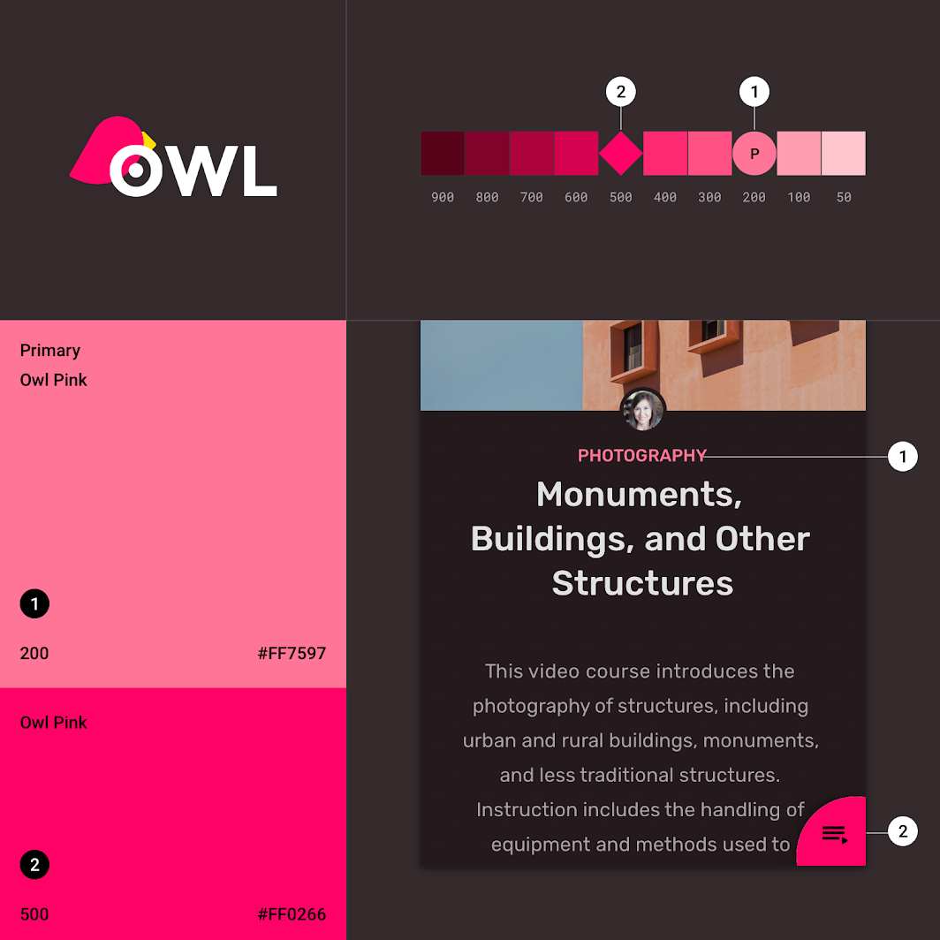

A fully saturated brand color is applied to the floating action button (2), while the desaturated dark theme primary color is applied to text (1).  
  
1. Dark theme primary color  
2. Brand color

[Owl](https://m2.material.io/design/material-studies/owl.html" \o "Owl" \t "_self)

[Owl is an educational app that provides courses for people who want to explore and learn new skills.](https://m2.material.io/design/material-studies/owl.html" \o "Owl" \t "_self)

[Related articlearrow\_downward](https://m2.material.io/design/material-studies/owl.html" \o "Owl" \t "_self)

**The dark theme baseline palette**

The Material Design baseline theme includes tonal palettes for a dark theme. Dark theme colors should be used across a dark theme UI, including:

The Material Design baseline theme includes tonal palettes for a dark theme.

Dark theme colors should be used across a dark theme UI, including:

* Color (primary, secondary, and primary color variants)
* Surfaces (backgrounds and components)
* States (such as error states)
* Content (typography and iconography)

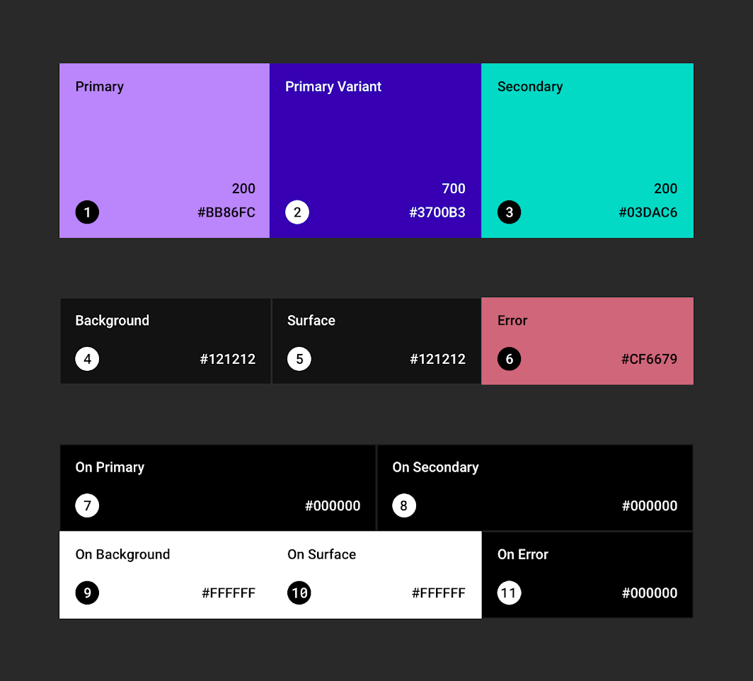

The dark theme baseline Material color theme

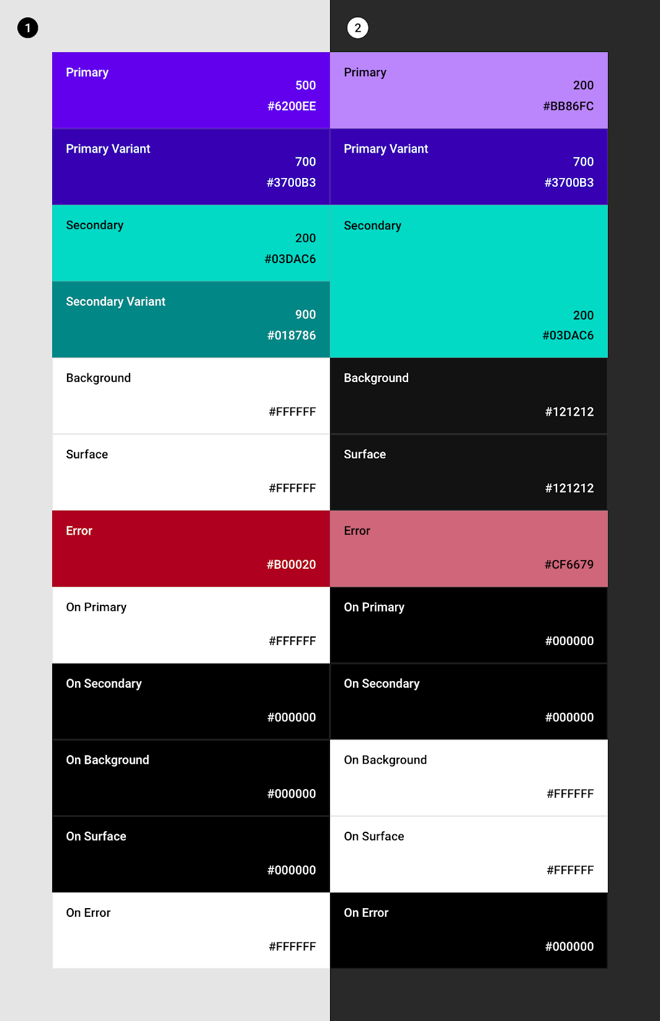

1. The Material Design baseline default theme  
2. The Material Design baseline dark theme

**Error colors**

Error colors are used to indicate an error state. The Material baseline dark theme error color is #CF6679.

Error colors are used to indicate an error state. The Material baseline dark theme error color is #CF6679.

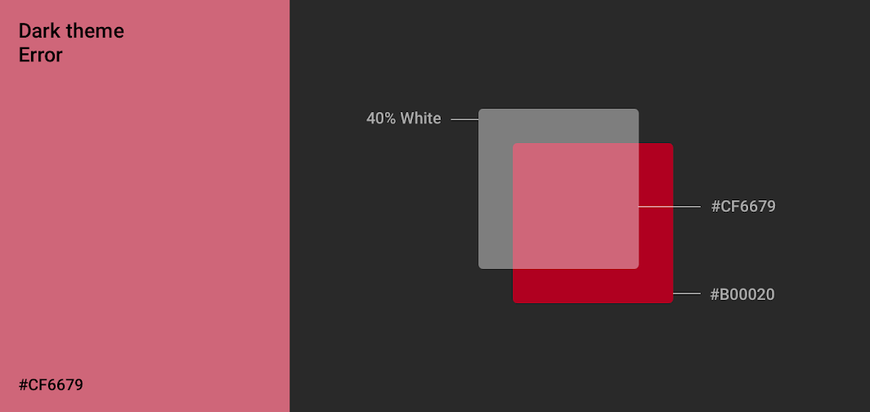

This dark theme color was created by taking the light theme error color (#B00020) and lightening it with a 40% white overlay, to pass AA-Level contrast standards.

**Typography and iconography colors**

"On" colors are primarily applied to text, iconography, and strokes that are sometimes placed "on" top of key surfaces that use a primary, secondary, surface,...

**"On" colors**

"On" colors are primarily applied to text, iconography, and strokes that are sometimes placed "on" top of key surfaces that use a primary, secondary, surface, background, or error color.

By default, dark theme “on” colors are white and black.

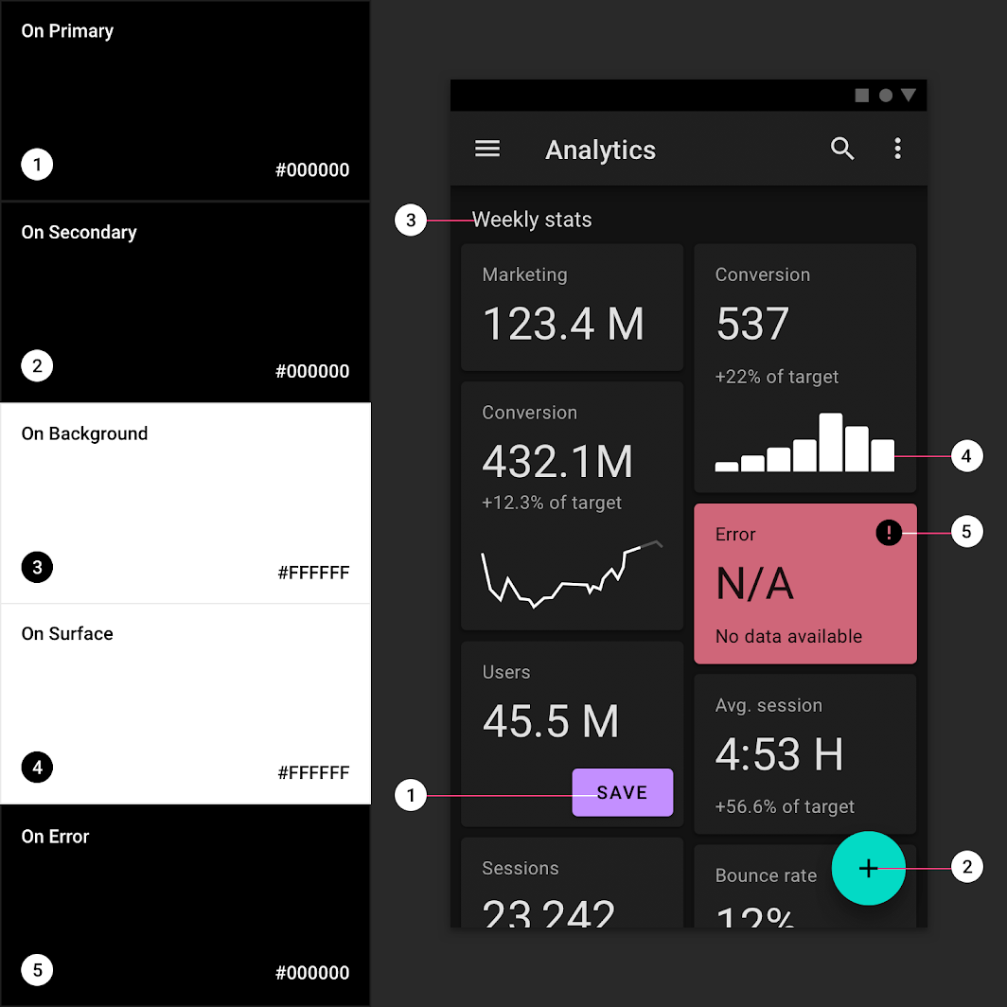

A UI displays the dark theme baseline colors for text and iconography.

**Light text on dark backgrounds**

When light text appears on dark backgrounds (shown here as white on black) it should use the following opacity levels:

* High-emphasis text has an opacity of 87%
* Medium-emphasis text and hint text have opacities of 60%
* Disabled text has an opacity of 38%

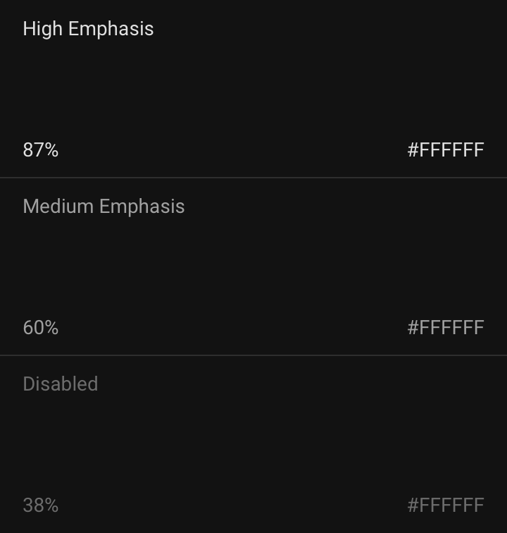

High-emphasis, medium-emphasis and disabled text

**Custom application**link

Some use cases in Material Design can benefit from using select dark theme elements.

**Large surfaces**

Components that use a large portion of a screen, such as an app bar or a backdrop, can use the dark theme for their component's surface color.

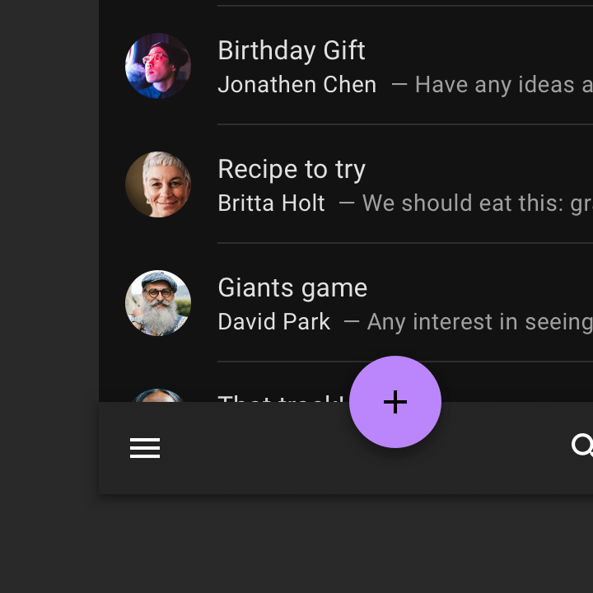

DoReserve bright colors for smaller surfaces.

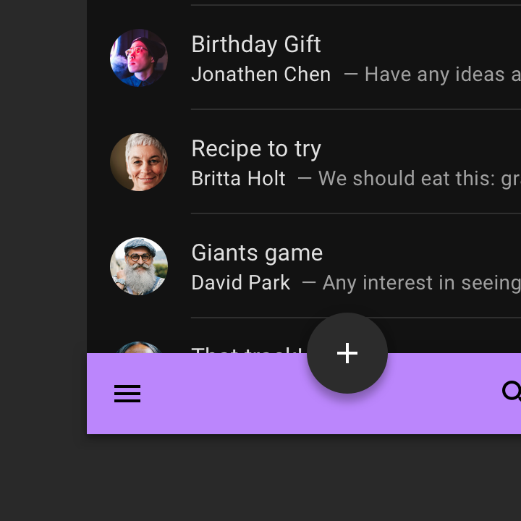

Don'tDon't use bright colors for large surfaces because they can emit too much brightness.

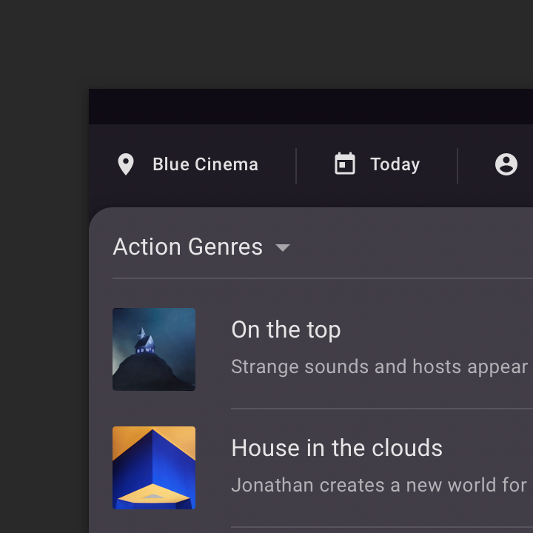

CautionIf a dark color is preferred instead of the recommended surface color (hex value #121212), ensure that it passes the 15.8:1 contrast ratio.

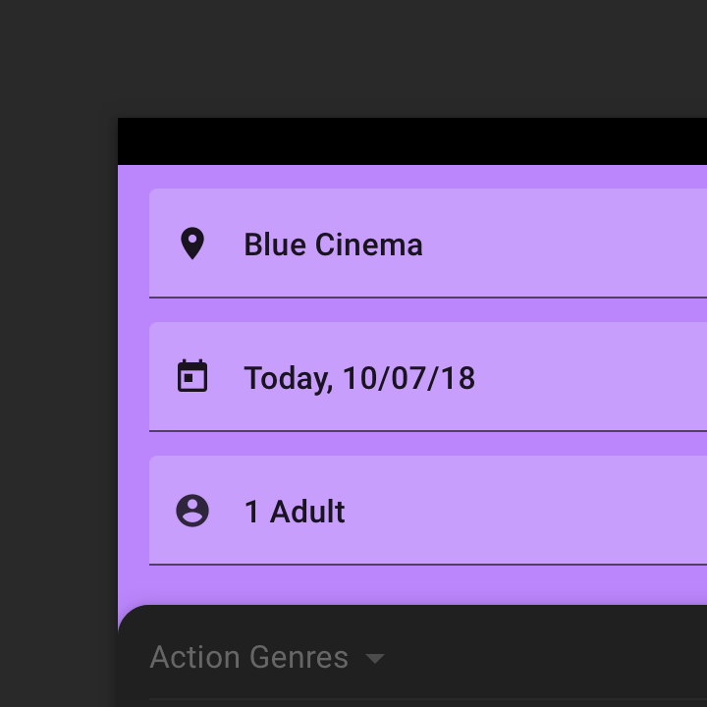

Don'tAvoid using the dark theme primary color for the backdrop because it covers a large portion of the screen with a light color.

**Combining light and dark themes**

When a light surface is needed in a dark theme, light coloring can be used on select component surfaces to preserve hierarchy.

For example, a dark theme snackbar can display a light surface to help it stand out. To do so, it can apply the light theme's Surface and On Surface colors.

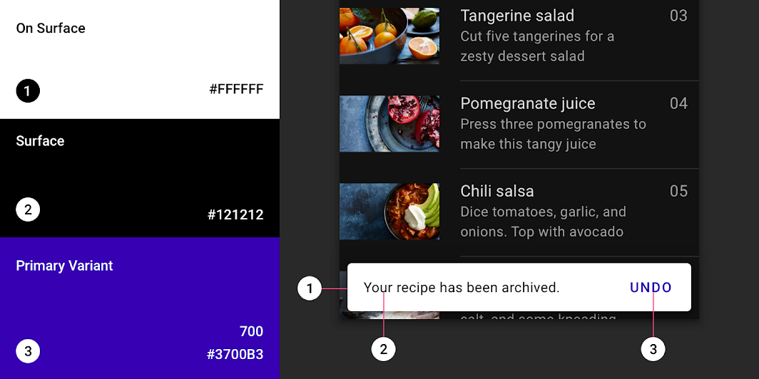

The snackbar uses a light surface in a dark theme to help it stand out.  
1. On Surface: #FFFFFF  
2. Surface: #121212  
3. Primary Variant: #3700B3

[Bottom app bars](https://m2.material.io/components/app-bars-bottom" \o "Bottom app bars" \t "_self)

[Provide reachable access to a bottom navigation drawer and actions on mobile devices.](https://m2.material.io/components/app-bars-bottom" \o "Bottom app bars" \t "_self)

[Related articlearrow\_downward](https://m2.material.io/components/app-bars-bottom" \o "Bottom app bars" \t "_self)

[Backdrop](https://m2.material.io/components/backdrop" \o "Backdrop" \t "_self)

[Displaying contextual & actionable content behind other surfaces](https://m2.material.io/components/backdrop" \o "Backdrop" \t "_self)

[Related articlearrow\_downward](https://m2.material.io/components/backdrop" \o "Backdrop" \t "_self)

[Snackbars](https://m2.material.io/components/snackbars" \o "Snackbars" \t "_self)

[Snackbars provide brief feedback about an operation through a message at the bottom of the screen.](https://m2.material.io/components/snackbars" \o "Snackbars" \t "_self)

[Related articlearrow\_downward](https://m2.material.io/components/snackbars" \o "Snackbars" \t "_self)

**States**link

States visually communicate the status of a component or interactive element through the use of overlays. In a dark theme, states should use the same [overlay](https://material.io/design/interaction/states.html#anatomy) values as their default (or light) theme, and they can be adjusted to pass AA-level contrast standards.

There are two types of containers that inherit state overlays: containers that use the "Surface" color and the "Primary" color.

**Surface containers**

Surface containers that use the color called "Surface" should apply an overlay that matches the color of their icon or text label (if no icon is present).

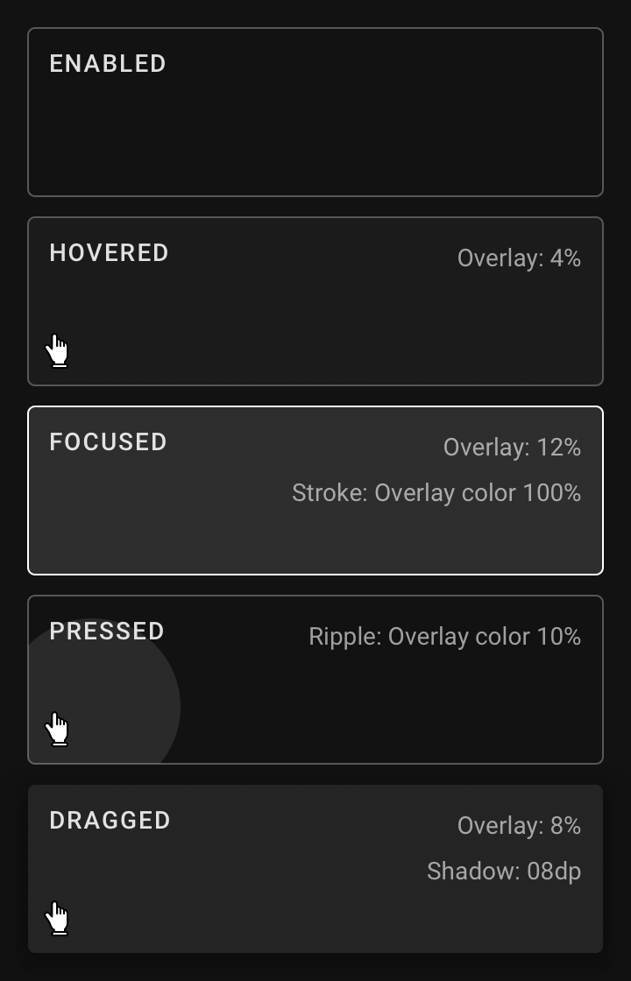

The enabled, hovered, focused, pressed, and dragged states for containers using the Surface color.

|  |  |
| --- | --- |
| Container | Surface |
| Content | On Surface |
| Overlay color | Inherited from content |

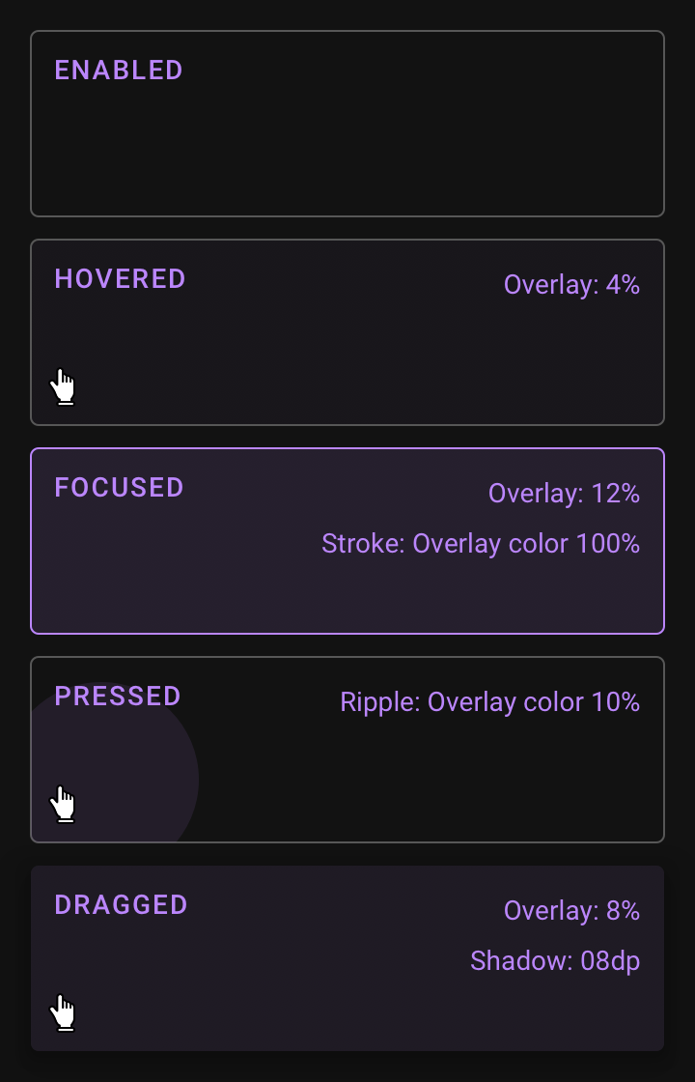

The enabled, hovered, focused, pressed, and dragged states for containers using the Surface color and the primary color for content.

|  |  |
| --- | --- |
| Container | Surface |
| Content | Primary |
| Overlay color | Inherited from content |

**Primary containers**

For surface containers that use the "Primary" color, their state overlay is white.

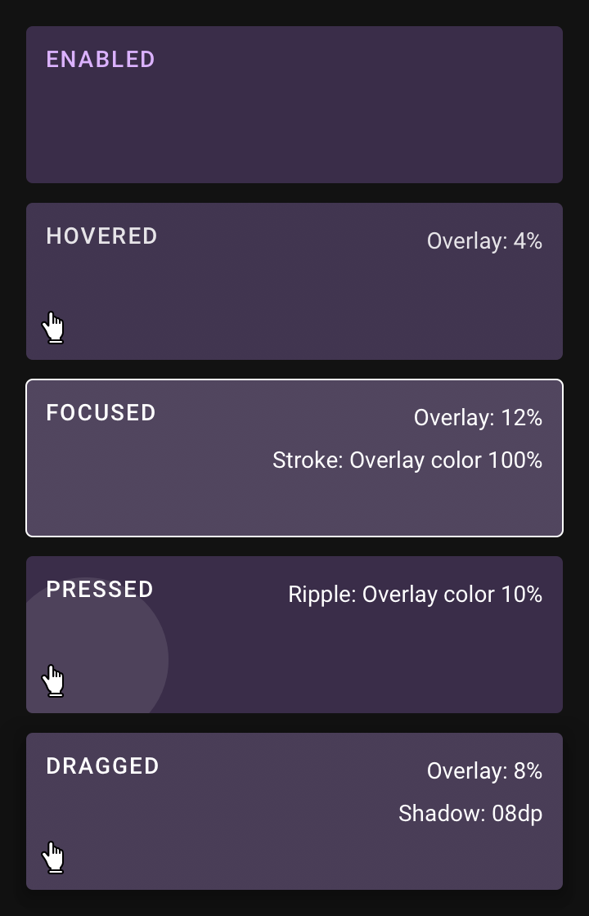

The enabled, hovered, focused, pressed, and dragged states for containers using the semi-transparent primary color.

|  |  |
| --- | --- |
| Container | Primary 24% |
| Content | Primary |
| Overlay color | White |

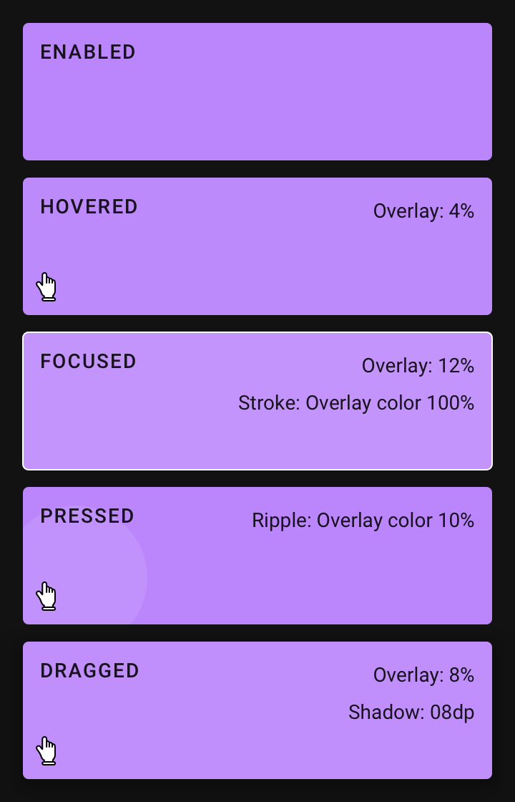

The enabled, hovered, focused, pressed, and dragged states for containers using the primary color.

|  |  |
| --- | --- |
| Container | Primary |
| Content | On Primary |
| Overlay color | White |

**Disabled states**

All disabled components are displayed using 12% White for container outlines and fills and 38% White for content such as labels or icons.

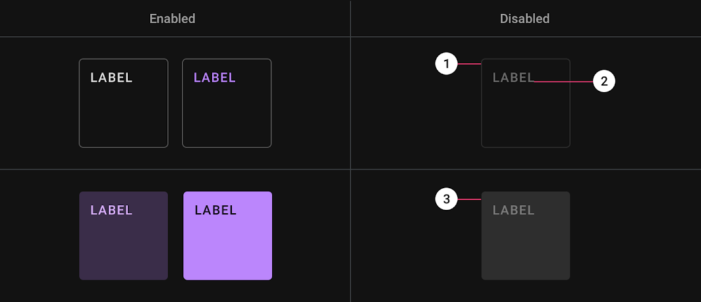

1. Outlined container: 12% White  
2. Label/Icon: 38% White  
3. Filled container: 12% White

[States](https://m2.material.io/design/interaction/states.html" \o "States" \t "_self)

[Visual representations used to communicate the status of a component or interactive element.](https://m2.material.io/design/interaction/states.html" \o "States" \t "_self)

[Related articlearrow\_downward](https://m2.material.io/design/interaction/states.html" \o "States" \t "_self)

**Resources**link

**Design files**

These design files include elements for dark theme layouts, such as status bars, app bars, bottom toolbars, cards, dropdown menus, side navs, dialogs, floating action buttons, and other components.

[DOWNLOAD FOR FIGMA](https://storage.googleapis.com/mio-assets/resources/Material%20Dark%20Theme%20Design%20Kit.fig" \o "" \t "_blank)

[DOWNLOAD FOR SKETCH](https://storage.googleapis.com/material-design/downloads/material-design-stickersheet.sketch)

*Available under*[*Apache 2.0.*](https://www.apache.org/licenses/LICENSE-2.0.html)*By downloading, you agree to the*[*Google Terms of Service.*](https://policies.google.com/terms)*The*[*Google Privacy Policy*](https://policies.google.com/privacy)*describes how data is handled in this service.*

**Implementation**link

Dark theme implementation support for each platform is indicated below.

| Platform | Status |
| --- | --- |
| Android | [Available](https://material.io/develop/android/theming/dark/) |
| iOS | Planned |
| Web | Planned |
| Flutter | Planned |

**Up next**

**[Typography](https://m2.material.io/design/typography/the-type-system.html" \o "The type system" \t "_self)**

**[The type system](https://m2.material.io/design/typography/the-type-system.html" \o "The type system" \t "_self)**

**[Color](https://m2.material.io/design/color/the-color-system.html" \o "Color theme creation" \t "_self)**

**[Color theme creation](https://m2.material.io/design/color/the-color-system.html" \o "Color theme creation" \t "_self)**

**[Environment](https://m2.material.io/design/environment/elevation.html" \o "Depicting elevation" \t "_self)**

**[Depicting elevation](https://m2.material.io/design/environment/elevation.html" \o "Depicting elevation" \t "_self)**

Material is an adaptable system of guidelines, components, and tools that support the best practices of user interface design. Backed by open-source code, Material streamlines collaboration between designers and developers, and helps teams quickly build beautiful products.

* [GitHub](https://www.github.com/material-components)
* [Twitter](https://www.twitter.com/materialdesign)
* [YouTube](https://www.youtube.com/materialdesign)
* [Blog RSS](https://m2.material.io/feed.xml)
* [Privacy Policy](https://policies.google.com/privacy)
* [Terms of Service](https://policies.google.com/terms)
* [Feedback](javascript:void(0))